
Functional Requirements Validation Document

Township of Manitouwadge 2026

Version 1.1

Table of contents
01 Introduction 4
01.1 Purpose 4
01.2 Scope 4
01.3 Document structure 4
01.4 Acronyms 5
02 In Scope 5
02.1 Pre-voting period 5
02.2 Online Voting 6
02.2.1 Landing page during voting process 6
02.2.2 In every page 7
02.2.3 Login page 9
02.2.4 Ballot pages 11
02.2.5 Review Page 14
02.2.6 Confirmation page 16
02.3 Post-Election 17
02.4 Supervision Dashboard 19
03 Open Points (Answer Required) 21
04 Out Of Scope 23
05 Approval 24

01 Introduction

01.1 Purpose
The purpose of the document is to:
- Explain Invoteʼs functionalities
- Gather customization requirements
- Detail the functionalities that are out of scope of this project

01.2 Scope
This document revolves around Invoteʼs functionalities, and does not include:
- Configuration details
- Voter Information Letter details
- These details will be gathered on a later date.

01.3 Document structure
The document is structured in the following manner:
- Invoteʼs functionalities that are within the scope of this project
- Invoteʼs functionalities that require clarification
- Functionalities that are out of scope of this project

01.4 Acronyms
Acronyms | Definition
AP | Admin Portal
VP | Voter Portal
VAPP | Verification App
OLV | Online Voting

02 In Scope

02.1 Pre-voting period
The following functionalities come into play before the beginning of the voting period.

Functionality | Description
Datafix integration | - Strike voters off the list once they have voted through any available voting channels.  - Deactivate a voterʼs voting credentials.  - Add new voters to the list and immediately generate new credentials for them.  - Update information from an existing elector (ward, date of birth, etc.).  - Generate new credentials for a voter (i.e. new PIN if they have lost the original one).
Zero out report | A report demonstrating that no votes were cast before the start of the voting period.

Landing Page Before active the period
Define what should be displayed before the active period starts.
Usually it is a message with the name of the election, date, and time when voting can begin.
✏️ Note: The desired message is detailed in section Open points (answer required).

English | French
Township of Manitouwagde  Welcome to the 2026 Municipal and School Board Election  Online voting will open on October 13, 2026 at 8:30 a.m | PENDING

02.2 Online Voting

02.2.1 Landing page during voting process
Define what should be displayed during the active period.
Usually it is a message with the name of the election, date, and the period for which the election is open.

English | French
Township of Manitouwagde  Welcome to the 2026 Municipal and School Board Election  Online voting is open until October 13, 2026 at 8:30 a.m.  Access the voting portal by clicking the "Next" button | PENDING
Information | Information

02.2.2 In every page
The following functionalities are present in every page.

Info button

Clicking the headerʼs info button opens a hover page that provides the following information on the Voter Portal:
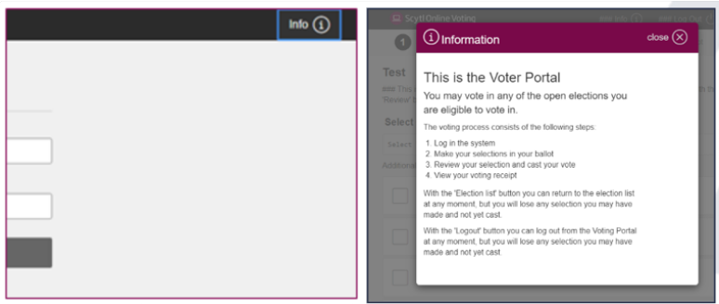

English | French
Welcome to the Voter Portal  The voting process has the following  steps;  - Log in to the system  - If you can vote in only one election:  - Select your options directly in the given ballot.  - Review your selection.  - Cast your vote.  - View your voting receipt and verification code (if the election has receipt number or verification code setup).  Note: With the “logout” button you can log out from the Voter Portal at any moment, but you will lose any  selection if you have not cast it yet. | Bienvenue à la Portail Électoral  Le processus du vote inclus les étapes suivantes;  - Se connecter au système  - Si vous pouvez voter en une seule élection:  - Marquez votre choix directement dans le bulletin qui se présente.  - Vérifie votre choix.  - Dépose votre bulletin.  - Consulte votre reçu de vote et code (si l’élection a un numéro de reçu ou code de vérification  configurer)  Note: Avec le bouton «Se Déconnecter» vous pouvez terminer votre session à n’importe quel moment, mais vous allez perdre vos choix si vous quittez avant que votre bulletin soit déposé.

Logout button
Voters can log out at any time by clicking on this button.

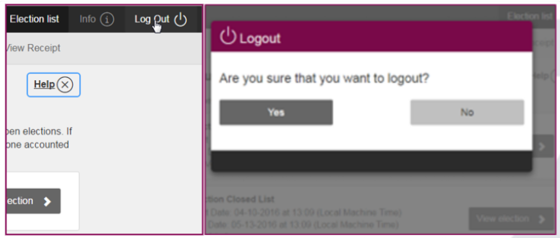

Once a voter logs out, the system will automatically redirect them to the specific exit URL requested by Manitouwagde.
✏️Note: This redirection applies exclusively to web voting. It does not apply to kiosk voting.

15-minute timeout

After 15 minutes of inactivity, the voter is logged out.

02.2.3 Login page
After navigating through the initial Landing Page, voters will reach the Login page. Correctly authenticating themselves on this page is a mandatory requirement to enter the Voter Portal and proceed to the ballot.

Functionality | Description
16-digit PIN to log in | To log in, the voter is prompted to enter their 16-digit login PIN provided in the Voter Information Letters.
Date of birth | With the following format:  Date of Birth (YYYY / MM / DD)
Language Selector | Since the election is configured in both English and French, a language dropdown option is available in the header. Voters can use this dropdown to seamlessly switch the interface language at any time.

The following provides the details for both language versions.
English | French
Login  Enter your PIN without spaces  Date of Birth (YYY / MMM / DDD) | Se connecter  Saisissez votre NIP sans espaces  Date de naissance (AAAA / MM / JJ)
Login | Se connecter

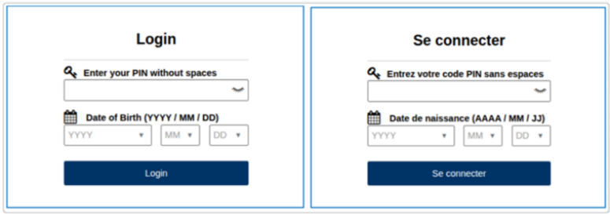

Position in voting process

Arrows on the top of the screen indicate whether the voter is in the “Vote”, “Review vote”, or “View receipt” phase of the voting process.
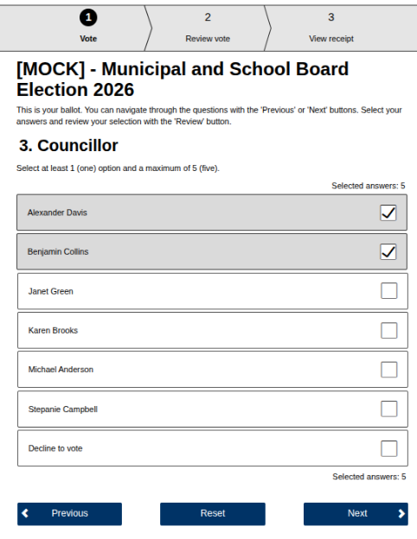

02.2.4 Ballot pages
Once authenticated, voters proceed directly to the ballot page for their election. This single ballot contains multiple questions. The voter marks their selections for each question on this stage and then proceeds to cast their vote.

Functionality | Description
Race name | The top of the page contains the configured race name.  ✏️ Note: An explanation text can be added during configuration to give more information.
Page explanation | An explanation text below the race name explains the page to the voter: “This is your ballot. Select the answers you want and review your selection with the ‘Reviewʼ button.”
Question | This field indicates the question the voter must respond to.  Example:  “Select your desired candidate for the position of Mayor.”  ✏️ Note: The exact wording of the questions is configured at a later stage. An explanation text can be added during configuration to give instructions.
Candidate list | The list of candidates the voter chooses from.  ✏️ Note: The list of candidates is displayed in alphabetical order.
Reset button | Clicking this button will deselect any selection.
Next button | Clicking this button will direct the voter to the next selection screen
Review button | This button saves your selection and takes you to the review page. It will appear on the final question

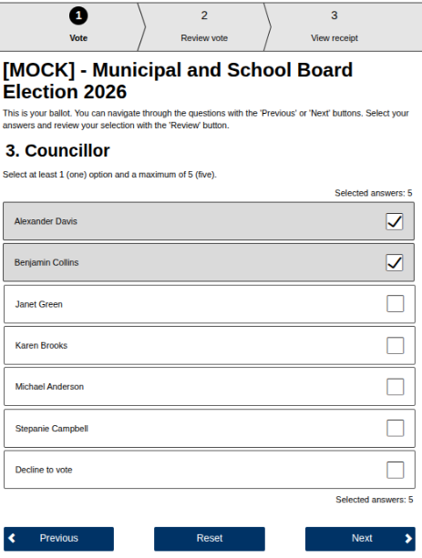
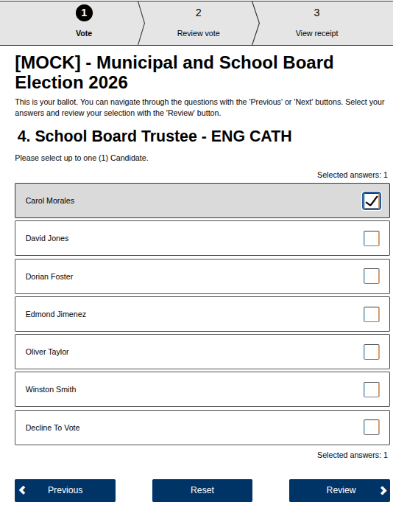

02.2.5 Review Page
This page displays the voterʼs selection for them to review before casting their vote.

Functionality | Description
Race name | The top of the page contains the configured race name.  ✏️ Note: An explanation text can be added during configuration to give more information.
Page explanation | An explanation text below the race name explains the page to the voter: “This is your ballot. Select the answers you want and review your selection with the ‘Reviewʼ button.”
Help button | Clicking this button unrolls an explanatory text:  “You can review your selection here. The ballot you can cast will consist of the selected options. If you wish to change them, do so with the ‘Change Voteʼ button. After reviewing your ballot, cast it by clicking the ‘Confirm Voteʼ button.”
Race question | This field indicates the question the voter responded to. Example: “Select your desired candidate for the position of Mayor.”
Selected answer | The candidate(s) the voter selected.
Change vote button | This button takes the voter back to the ballot page to change their selection.
Confirm vote button | This button casts the vote.

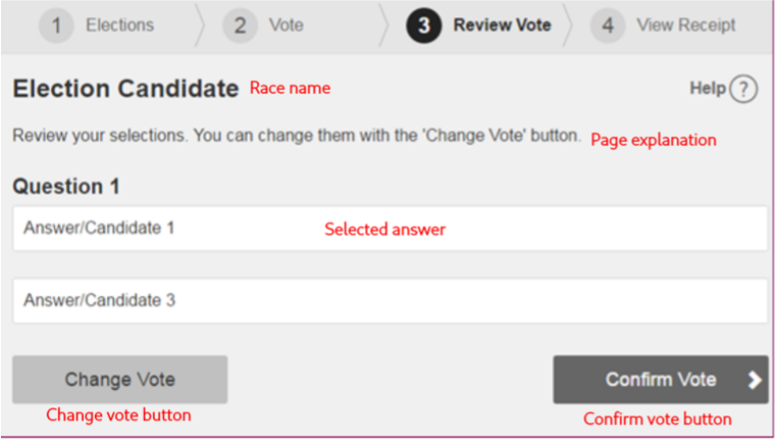

02.2.6 Confirmation page

This page is displayed after the voter has cast their vote and includes a confirmation message that their vote has been correctly sent, and their receipt code.

Functionality | Description
Confirmation message | A message displayed on top of the screen indicating the vote was sent correctly.
Race name | The top of the page contains the configured race name.
Page explanation | An explanation text below the race name explains the page to the voter: “The voting receipt is your digital certificate. Copy your voting receipt to verify your vote has been cast and stored correctly.”
Help button | An explanation text: “This is your receipt. You may copy it. If your device has printing capabilities, you may print it with the ‘Printʼ button.  You can finish the voting process with the ‘Exitʼ button.”
Receipt code | The receipt code voters can use to check that their vote was included in the count.
Control code | The control code is an additional verification mechanism to prove the authenticity of the receipt code.
Exit button | The exit button redirects the voter to the Ballot List.
Print button | The print button opens a window to print the receipt code.

02.3 Post-Election
The delivery of post-election reports will follow the same procedure used in 2025. The reports will be sent in a password-protected ZIP file via email to the address designated by the client. To ensure maximum security, the password to decrypt the file will be shared through a separate communication channel.

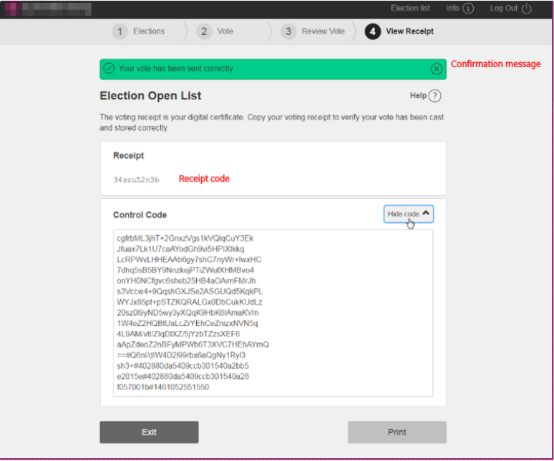

Report | Description
Participation | A participation file is provided with the following participation data:  - Voter ID  - Whether voter has voted  - Voting channel  - The vote’s timestamp  - Whether the voter is active  - Whether the voter is authorized  - The voter’s ward assignation  On top of this participation file, VoterView’s standard participation  reporting capabilities are available to the municipality
Result | A results file is provided with results:  - Per race  - Total votes  - Number of votes per candidate  - Number of spoiled ballots  - Number of declined ballots  - Per district  - Total votes  - Number of votes per channel  - Number of votes per candidate for that channel  - Number of spoiled ballots  - Number of declined ballots  - Number of blank votes
Receipt | A receipt file with the list of vote receipts included in the count

02.4 Supervision Dashboard
For this edition, voter participation data will be shared via daily email reports. Comitia will extract the turnout metrics twice a day and send them directly to the contacts indicated by The Township of Manitouwagde. The specific schedule for extracting and sending these reports will be agreed upon with The Township of Manitouwagde.

The details of the available indicators are outlined below:

Report | Description
Turnout | - Number of authorized voters  - Number of abstentions  - Number of voters who have voted
Ballots received | The number of ballots received in the ballot box.
Election results | Results are displayed in the following manner:  - Race question  - Votes per candidates  - Number of declined ballots  - Results by ward  - Votes per candidates  Number of declined ballots

03 Open Points (Answer Required)

Description | Decision
A page displayed before the login page that contains:  - Election name  - Button to reach the login page | - Yes  - No
The voter is allowed to not select any candidate. In this case, their vote will count as implicit blank for that race. | - Yes  - No
The Voter is able to select less than the maximum number of candidates.  ✏️ Note: For this election, only one seat is available for Councillor. Therefore, undervoting is not applicable. | - Yes  - No
The voter can select a “Decline to Vote” option displayed at the end of the list of candidates for  each race. Clicking this will deselect other options and when cast, will count as a declined  vote for that race. | - Yes  - No
The voter can select a “Spoil this ballot” option displayed at the end of the list of candidates for  each race. Clicking this will deselect other options and when cast, will count as a spoiled  vote for that race. | - Yes  - No
Warn about undervote  When the voter selects less than the maximum amount of candidates, they are prompted with a warning message when they review their vote before casting it. | - Yes  - No
The voter’s credentials consist of the PIN and their date of birth. Voters input their Date of Birth by either entering their birth year/month/day, or by selecting the relevant value from a dropdown.  ✏️ Note: If you select “No”, the credentials will only consist of the 16-digit PIN. | - Yes  - No
If an Exit URL is configured, the voter will be redirected to this URL when clicking the “Log Out” button.  ✏️Note: There is no exit URL for kiosks. | - Yes  - No

04 Out Of Scope

The following items are out of scope. They can be included, but as Change Requests.

Report | Description
Other ballot language than English and French | Additional Voter Portal interface language apart from English and French.
Online credential delivery (email with voting credentials and link to voting URL) | Sending voters their credentials through their email instead of through postal mail.
Voter Portal text configurability | Editing the Voter Portal’s texts that are not set during configuration, i.e., any Voter Portal interface texts outside of the Election name, questions, question explanations, and candidate names, as detailed in the section below.
Overvoting | The voter is able to select more than the maximum number of candidates.
Exit surveys | Comitia does not provide satisfaction surveys for voters to fill in after having voted.

05 Approval

The undersigned acknowledge that they have reviewed the Functional Requirements Specifications Document and agree with the information presented within this document. Changes to this document will be coordinated with, and approved by, the undersigned, or their designated representatives.

Township of Manitouwagde | Comitia

